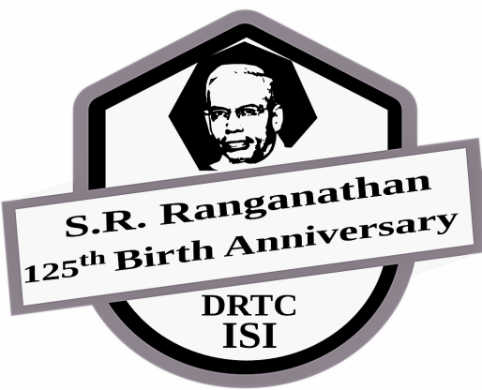 | Commemorating the 125th birth centenary of Prof. S.R.Ranganathan  International Conference on  Exploring the Horizons of Library and Information Sciences:  from Libraries to Knowledge Hubs  7 – 9th August 2018  Documentation Research and Training Centre  INDIAN STATISTICAL INSTITUTE, Bangalore Centre

Accommodation Form

Name: Designation :

Gender : M / F

Name, Age and Gender of accompanying person(s) (if any):

Complete address (including Phone):

Date of approximate arrival:

Date of approximate departure:

Type of accommodation required: single/shared room

Total Amount : No. of Days * 850/750 * No. of Persons _____________________________

--------------------------------------------------------------------------------------------------------------------------------------------------
Accommodation Charges:

- Single - Rs. 850/- (includes breakfast and dinner) per day
- Shared - Rs. 750/- per head (includes breakfast and dinner) per day

Payment Details

DD / On-line Transaction No. | : |  | Amount:
Bank / Branch | : |  | Date:

Demand Draft (DD) should be made in favour of Indian Statistical Institute, Payable at Bangalore.
Hard copy of DD should be sent to: Head, DRTC, Indian Statistical Institute, 8th Mile Mysore Road, RVCE Post, Bangalore, Karnataka, 560059.

Online Payment Details:
a. Name : Indian Statistical Institute
b. Bank : UCO Bank, Kengeri Branch, Mysore Road, Bangalore
c. Account No. : 02970200000702
d. IFSC Code : UCBA0000297
e. Type of Account : Current Account
f. Swift code (in case of non-Indians) : UCBAINBB306
Note: Please mention the participant name in Remark /comment column while making online payment.
The “transactions completed” screen may be saved. The same may be sent through email.
Online payment receipt along with duly filled Registration Form should be sent via mail to srr125@drtc.isibang.ac.in

