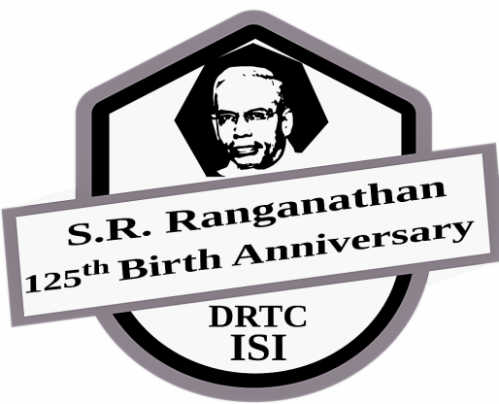 | Commemorating the 125th birth centenary of Prof. S.R.Ranganathan  International Conference on  Exploring the Horizons of Library and Information Sciences:  from Libraries to Knowledge Hubs  7 – 9th August 2018  Documentation Research and Training Centre  INDIAN STATISTICAL INSTITUTE, Bangalore Centre

Registration Form

Participant Name :
e-mail :
Mobile :
Address :

Accommodation required : Yes / No If, Yes: Single / Shared

For Organisation Sponsored participants

Organisation | :
Contact Person | :
Mailing Address | :
Email | : |  | Phone:
 |  |  | Mobile:

Details of International Delegates

Passport Number: Place of Issue:
Date of Expiry: Nationality (as in passport):
Date of Issue/ Last Renewal:

DECLARATION
I………………………………………………………………………………hereby declare that the information provided above is true to the best of my knowledge. Any deviation (whenever found) from the information provided is solely my responsibility, for which I may be penalized by appropriate authorities.

Signature: Name: Date:

Registration Fee:
India & SAARC Countries: Rs. 3,500/-
Students* and retired professionals (India and SAARC): Rs. 2,500/-
Other Countries: USD 100

*Applicable to full time students on providing valid proof

Page 1 of 2

Payment Details

DD / On-line Transaction No. | : |  | Amount:
Bank / Branch | : |  | Date:

Demand Draft (DD) should be made in favour of Indian Statistical Institute, Payable at Bangalore.
Hard copy of DD should be sent to: Head, DRTC, Indian Statistical Institute, 8th Mile Mysore Road, RVCE Post, Bangalore, Karnataka, 560059.

Online Payment Details:
a. Name : Indian Statistical Institute
b. Bank : UCO Bank, Kengeri Branch, Mysore Road, Bangalore
c. Account No. : 02970200000702
d. IFSC Code : UCBA0000297
e. Type of Account : Current Account
f. Swift code (in case of non-Indians) : UCBAINBB306
Note: Please mention the participant name in Remark /comment column while making online payment.
The “transactions completed” screen may be saved. The same may be sent through email.
Online payment receipt along with duly filled Registration Form should be sent via mail to srr125@drtc.isibang.ac.in

Terms and Conditions
- Registration forms will not be accepted without registration fee
- No request for refund of the registration fee (fully or partially) will be entertained.
- Participation is confirmed after receipt of
a. Filled in application form
b. Conference fee in full (Cash, DD or online transfer)
4. ISI will provide a receipt for the payment received after the start of the course. The same to be used as a proof of payment. ISI accounting system does not entertain any other form of documentation.
5. Single / shared accommodation (limited number) can be availed as a first-come-first-served basis at a nearby guest house/hotel on extra payment basis.
6. Any participant applied for the program is understood to have gone through and accepted these terms and conditions.
Send the filled in form along with fee details to:

The Head
Documentation Research and Training Centre
Indian Statistical Institute
8th Mile Mysore Road,
RVCE Post, Bangalore,
Karnataka 560059, INDIA
Page 2 of 2

